

TRAINLY.IO DATABASE DESIGN

CS5200 – DATABASE MANAGEMENT SYSTEMS

FALL 2017

CLASS PROJECT SUBMITTED TO

PROFESSOR NATHANIEL DERBINSKY

BY

DING LI (NUID: 001645095)

RAVI KRISHNAN IYER (NUID: 001857260)

KHOZEMA LOKHANDWALA (NUID: 001621853)

QIANPENG ZHENG (NUID: 001882559)

BOSTON, MASSACHUSETTS

DATE: 12/11/2017

**Abstract**

In this project, we are trying to create a web application which can deal with the university management system. The app created should be able to perform student registration, faculty registration and administrator registration. And the student can choose courses they want, post questions to the course, the faculty can create courses, and the administrator can authenticate users and perform some certain tasks.

Trainly.io is an App for training students which allows organizations to collaborate with faculty to create and securely post courses and study materials, for students, each student can search for, enroll in, and complete useful courses. The database has the basic information of students, faculties and administrators. Students will be able to view courses by topics, and post questions to the faculty members in case of doubts. Faculty can create courses, make the course questions visible. Administrator can authenticate users as faculty or administrator, and he can perform certain tasks like extract account history for a user. Trainly.io makes money by charging 30% of the course enrollment fees.



**Textual Description**

**USER MANAGEMENT**

A user can register as a student (by default), a faculty and/or an administrator. During registration, a user provides its first name, last name, email address, a password, a profile picture, contacts number(s) and an address consisting of street, city, postal code and country. Each user is assigned a unique ID. User who are faculty members are always authenticated by an administrator after user registration. Administrators have various positions within the system and are granted their role by another administrator. If the user is a faculty, it should provide title, work website and affiliation for validation by an administrator. Whenever faculty is authenticated, date/time of the authentication and the ID of the administrator who validated are both recorded. We have assumed that the first administrator will already be added to the system. And we already insert sets of data in the system. User’s password is securely stored in a password table and it is hashed with salt.

**COURSES**

Faculties that are authenticated can create courses and students can take courses. Student can also be interested in multiple courses. Each course has a unique ID, name, description, icon, primary topic, cost and any number of secondary topics. Each topic has a unique ID and a name. When a student pays for a course, the date/time, amount paid, and confirmation code is recorded. A course also has ratings (1-5) and comments from the students who have completed their course. When a student completes a course, the date/time of the completion is recorded for certification requests. And there is a link to the certificate.

**COURSE MATERIALS**

A course has a list of materials to be completed and each material is unique to the course. A material has a unique material ID, material sequence ID, name and a type and completion date/time of a material by a student is also recorded. The type of the material can one of the three types: a link which has a URL and a video tag (telling if the video is tagged or not), downloadable files which have path, size and type and post which is basically a block of text. The material list of a course should be completed in sequence by the student and date/time of each material completion is recorded. When all the materials of a course are completed by a student, the course is completed by the student.

**QUESTIONS**

A question has a unique question line ID. Students can ask question related to a material or a course to the faculty creators and faculty can review and answer them. Students can also like the questions they find useful and the number of likes gives the ranking of the questions on the website. A faculty can make a question visible to other student if he/she finds the question useful to others.

**ER Diagrams**



**Normalized Relations**

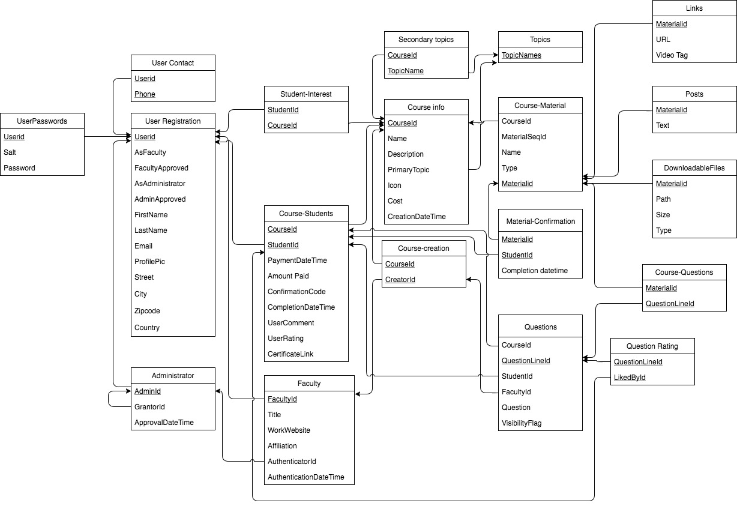

**Relations:**

**All the relations in this schema are in 3NF except *Course-Student* and *Question*. First the domain of an attribute includes atomic values in all the relations, so it is in 1NF, second, all the non-prime attributes are fully FD on the primary keys, finally, every attribute is non-transitively FD on every key for all the relations. And for *Course-Student* Amount Paid is dependent on CourseId, which is a violation of 2NF, for *Questions* Question and Visibility Flag are dependent on QuesionLineId, which is a violation of 2NF. But we decide to keep it to improve the performance.**

**User Registration**: Primary Key {Userid}.

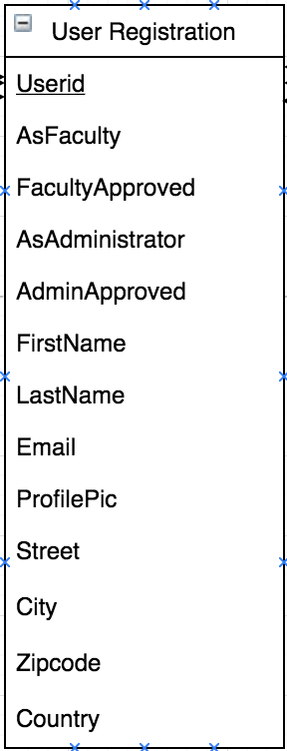

**User Contact:** Primary Key {Userid, Phone}. Foreign Key {Userid} reference to *User Registration*

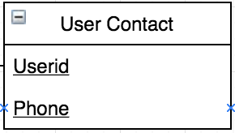

**User Passwords:** Primary Key {Userid}. Foreign Key {Userid} reference to *User Registration*

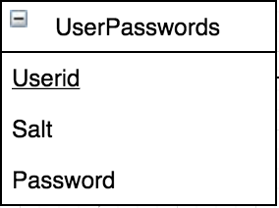

**Administrator:** Primary Key {AdminId}. Foreign Key {AdminId} reference to *User Registration*, {GrantorId} reference to *Administrator*

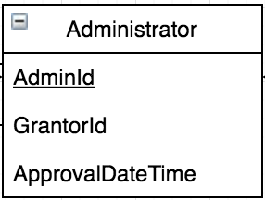

**Student-Interest:** Primary Key {StudentId, CourseId}. Foreign Key {StudentId} reference to *User Registration*, {CourseId} reference to *Course Info.*

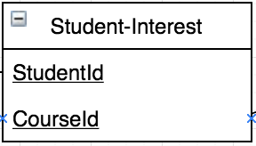

**Course-Students:** Primary Key {StudentId, CourseId}. Foreign Key {StudentId} reference to *User Registration*, {CourseId} reference to *Course Info.*

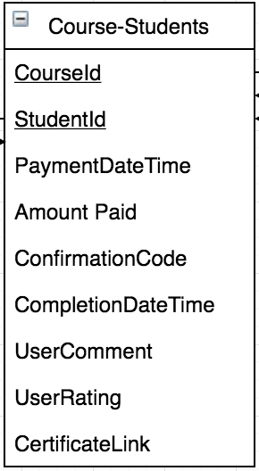

**Faculty:** Primary Key {FacultyId}. Foreign Key {FacultyId} reference to *User Registration*, {AuthenticatorId} reference to *Administrator.*

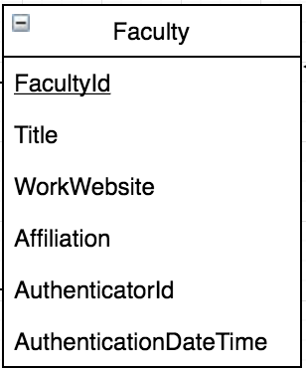

**Course Info:** Primary Key {CourseId}. Foreign Key {Primary Topic} reference to *Topics*.

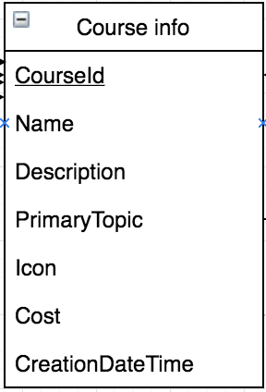

**Course-Creation:** Primary Key {CreatorId, CourseId}. Foreign Key {CreatorId} reference to *Faculty*, {CourseId} reference to *Course Info.*

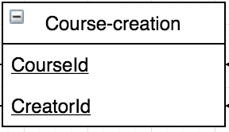

**Secondary Topics:** Primary Key {TopicName, CourseId}. Foreign Key {TopicName} reference to *Topics*, {CourseId} reference to *Course Info.*

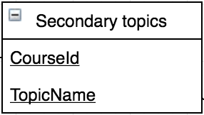

**Topics:** Primary Key {TopicNames}.

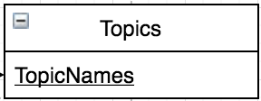

**Course-Material:** Primary Key {Materialid}. Foreign Key {CourseId} reference to *Course Info.*

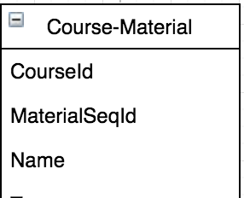

**Material-Confirmation:** Primary Key {StudentId, Materialid}. Foreign Key {Materialid} reference to *Course-Material*, {StudentId} reference to *Course-Students.*

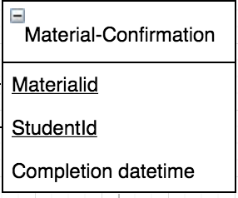

**Questions:** Primary Key {QuestionLineId, FacultyId}. Foreign Key {StudentId} reference to *User Registration*, {CourseId} reference to *Course-Students,* {FacultyId} reference to *Course-Students.*

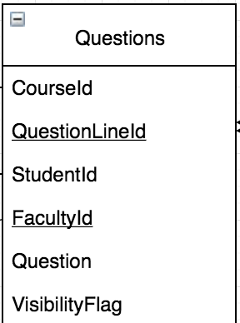

**Links:** Primary Key {Materialid}. Foreign Key {Materialid} reference to *Course-Material*

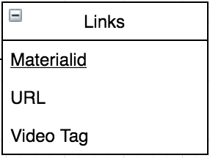

**Posts:** Primary Key {Materialid}. Foreign Key {Materialid} reference to *Course-Material*

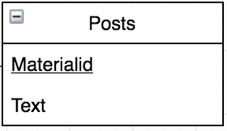

**DownloadableFiles:** Primary Key {Materialid}. Foreign Key {Materialid} reference to *Course-Material*

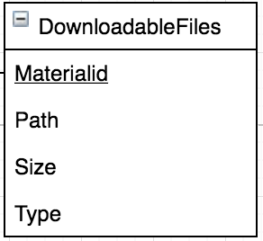

**Course-Questions:** Primary Key {Materialid, QuestionLineId}. Foreign Key {Materialid} reference to *Course-Material*, {QuestionLineId} reference to *Questions*

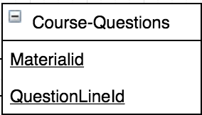

**Question Rating:** Primary Key {LikeById, QuestionLineId}. Foreign Key {LikeById} reference to *Course-Students*, {QuestionLineId} reference to *Questions*

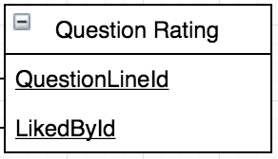

**Physical Design**

For the physical design part, all our queries are executing fast and well, so we didn’t create and indexes. our database doesn’t have a lot of data, the query performance is well, so we did not implement a lot of de-normalizations, only in the *Questions* table and *Course-Students* Table And we think that the database performs well for probably two reasons, one is that our DML is well designed, the other is that we have a relatively small database.

**Database Screenshots**



This is the index page for login.

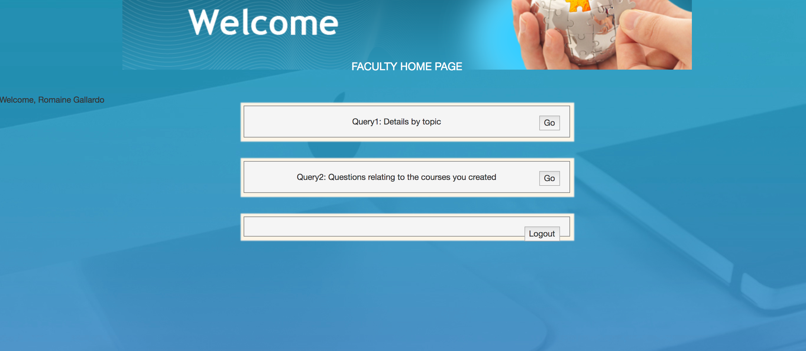

Log in as a faculty.

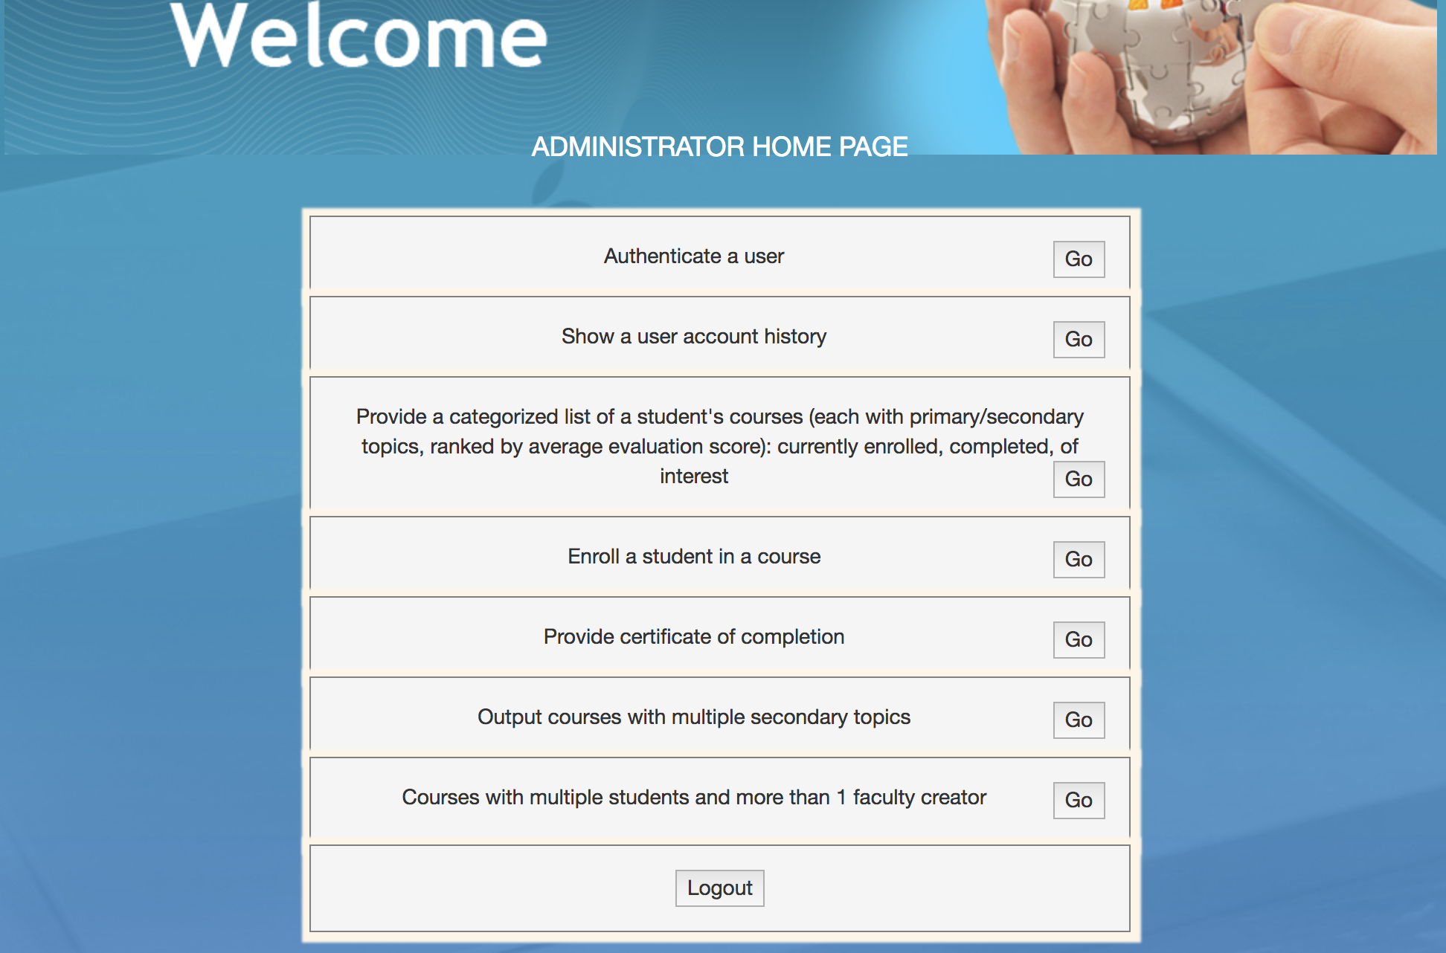

Log in as an administrator.

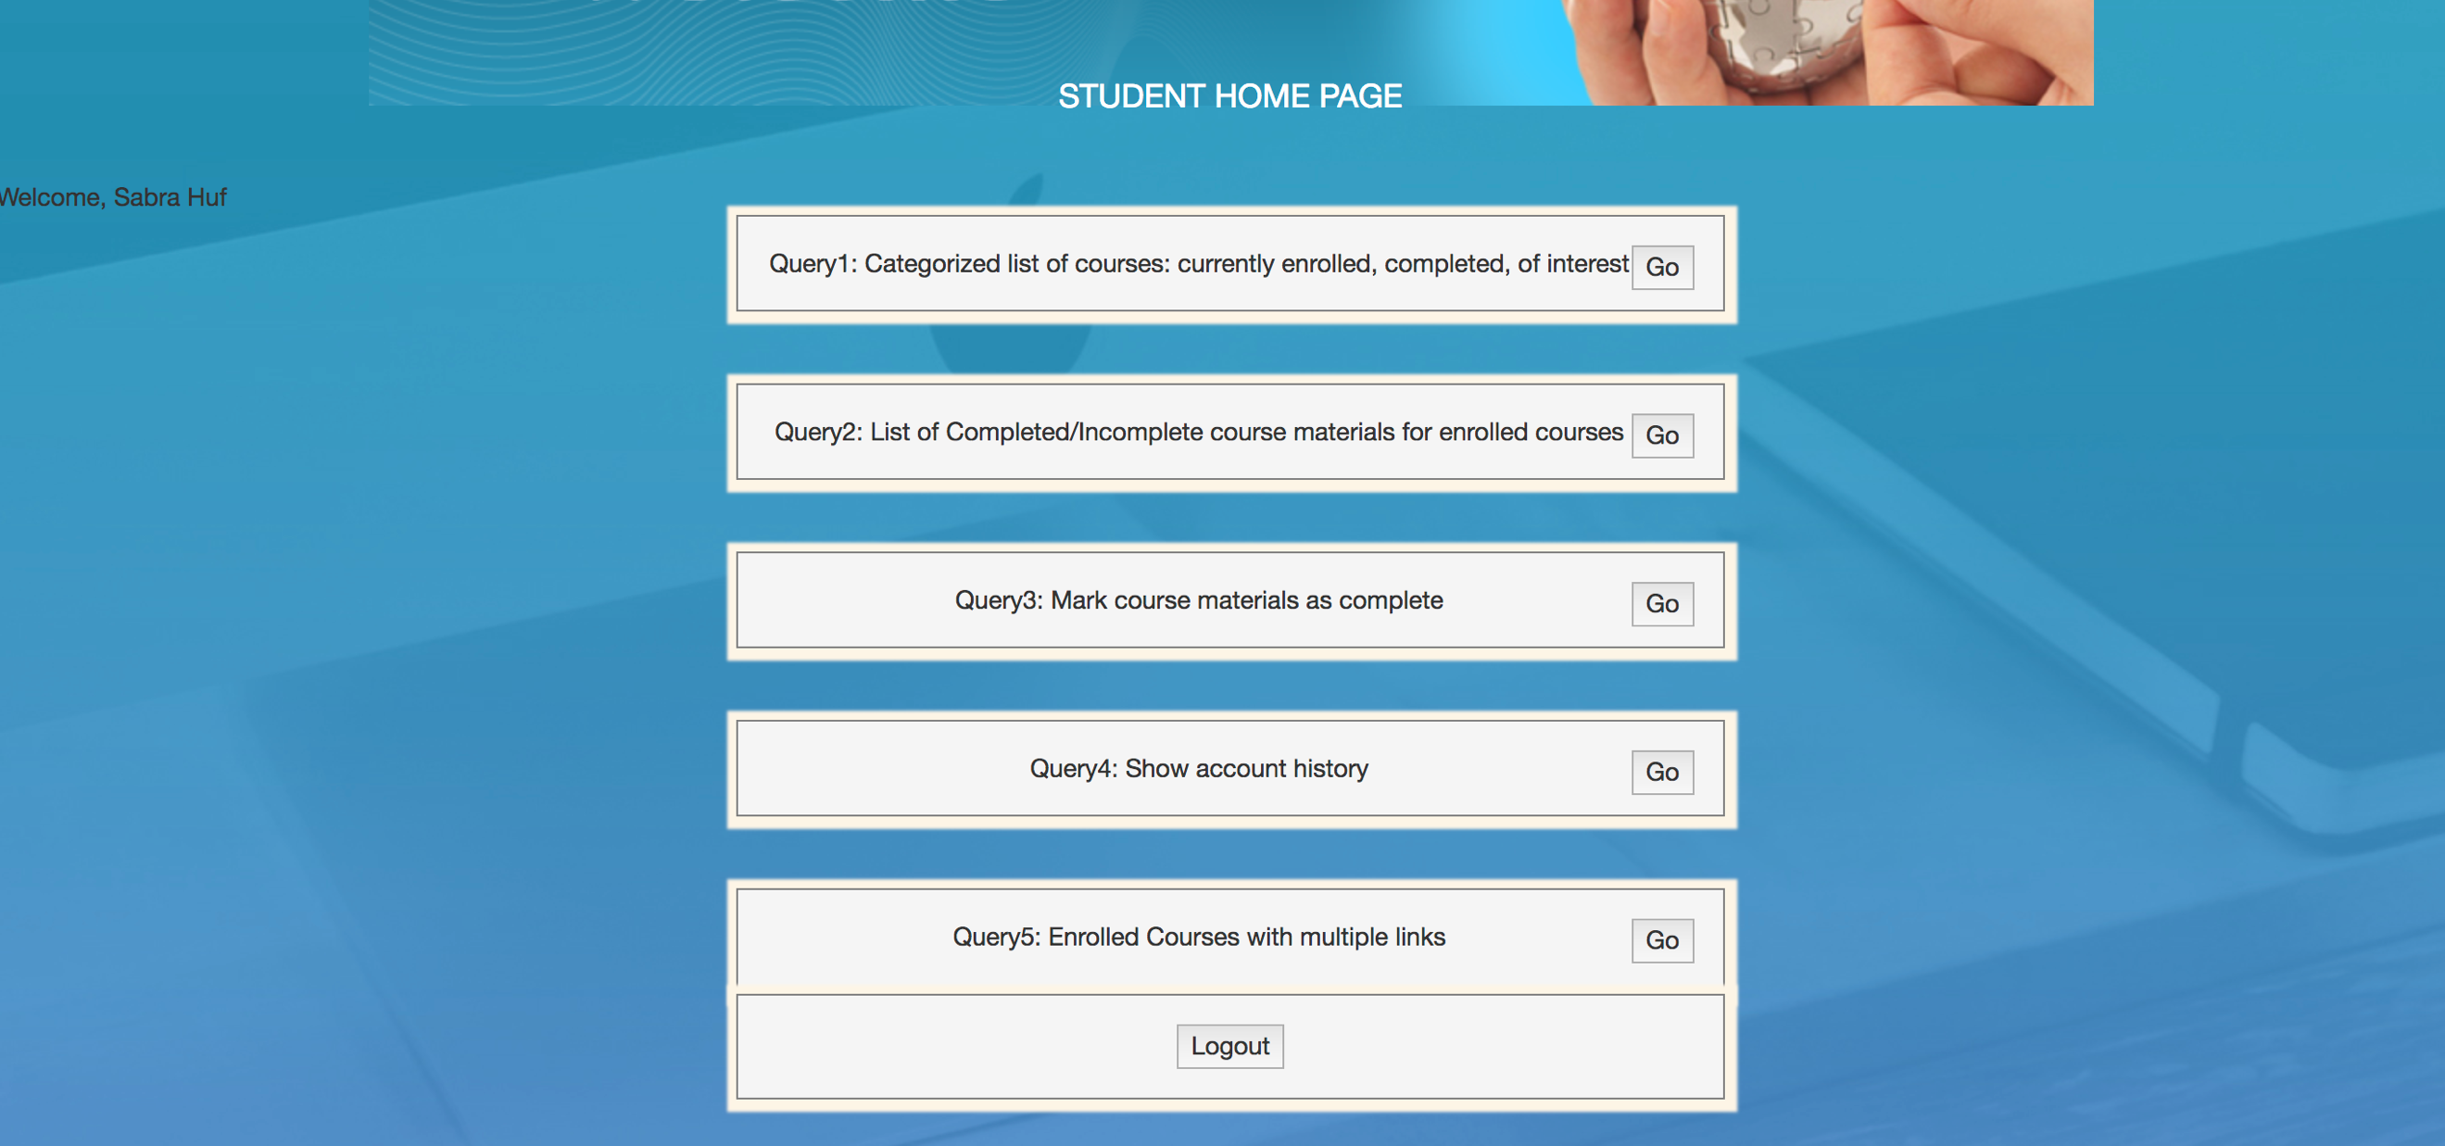

Log in as a student.

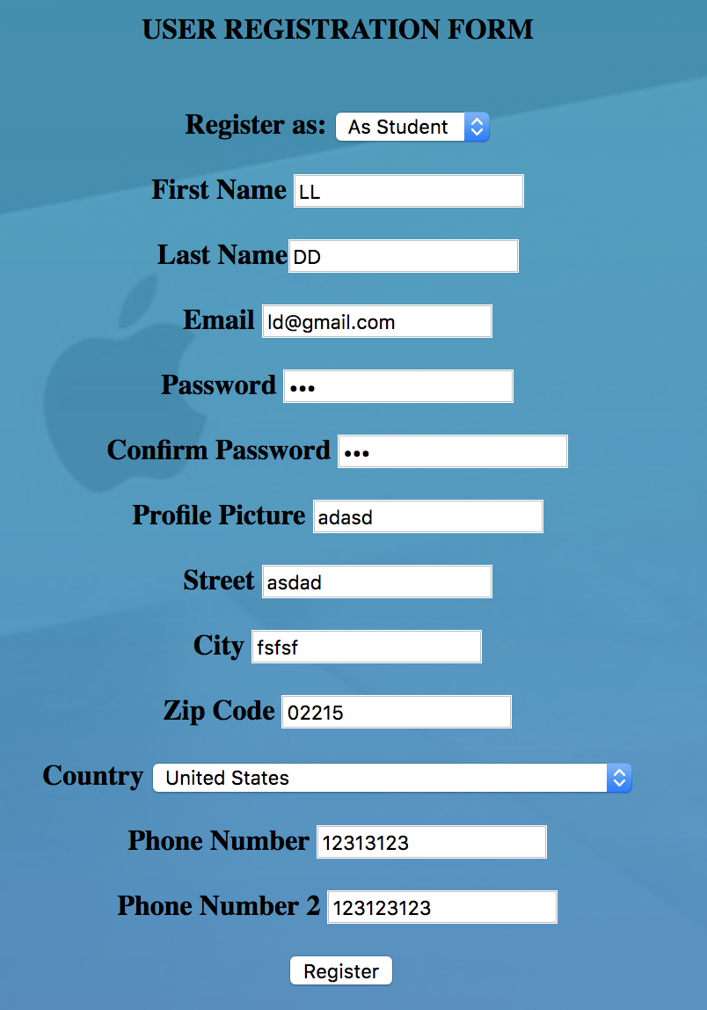

The above is the Task A form. After Click “Register”, it will say “done” and redirect to index page.

Also, we can register as a faculty or administrator, and all the things we need to do is to fill another form like below:

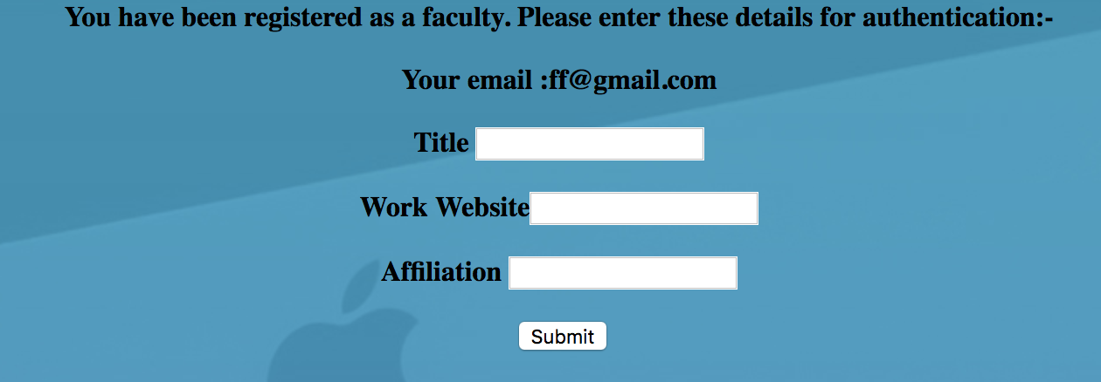

And then everything is done for Task A.

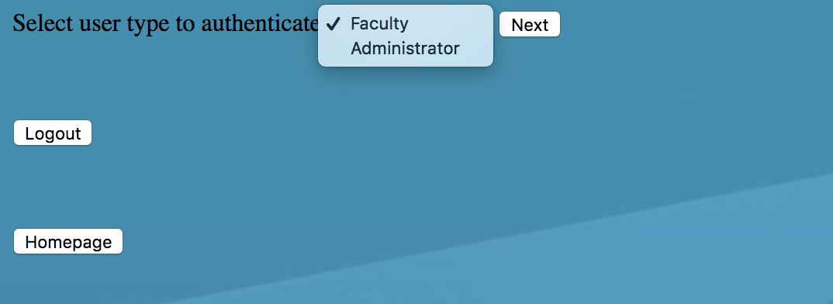

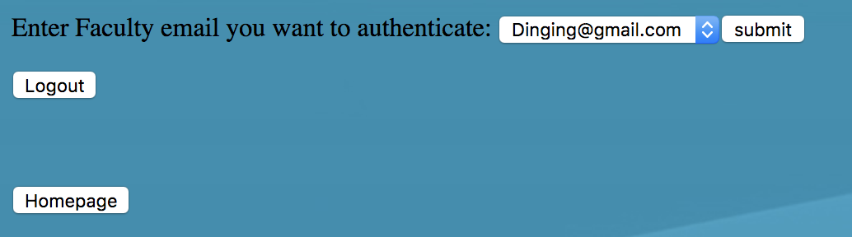

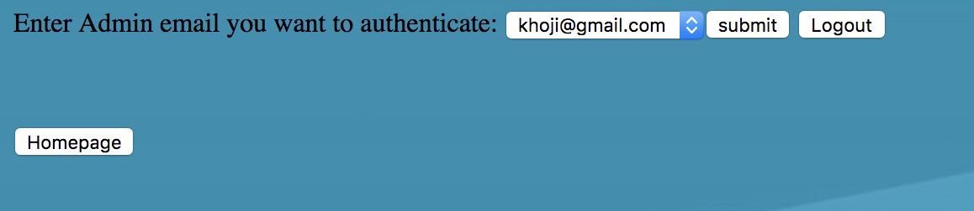



The above forms are the Task B forms, and in our database right now there is one user register as a faculty whose email is [Dinging@gmail.com](mailto:Dinging@gmail.com) but not approved yet, also one user register as an administrator whose email is [khoji@gmail.com](mailto:khoji@gmail.com) but not approved yet, just choose the type and user then you can authenticate. The success means it is done.

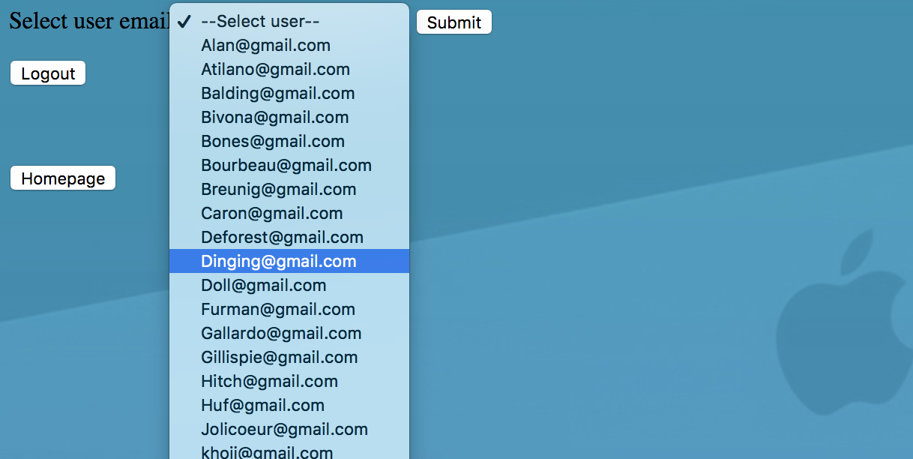

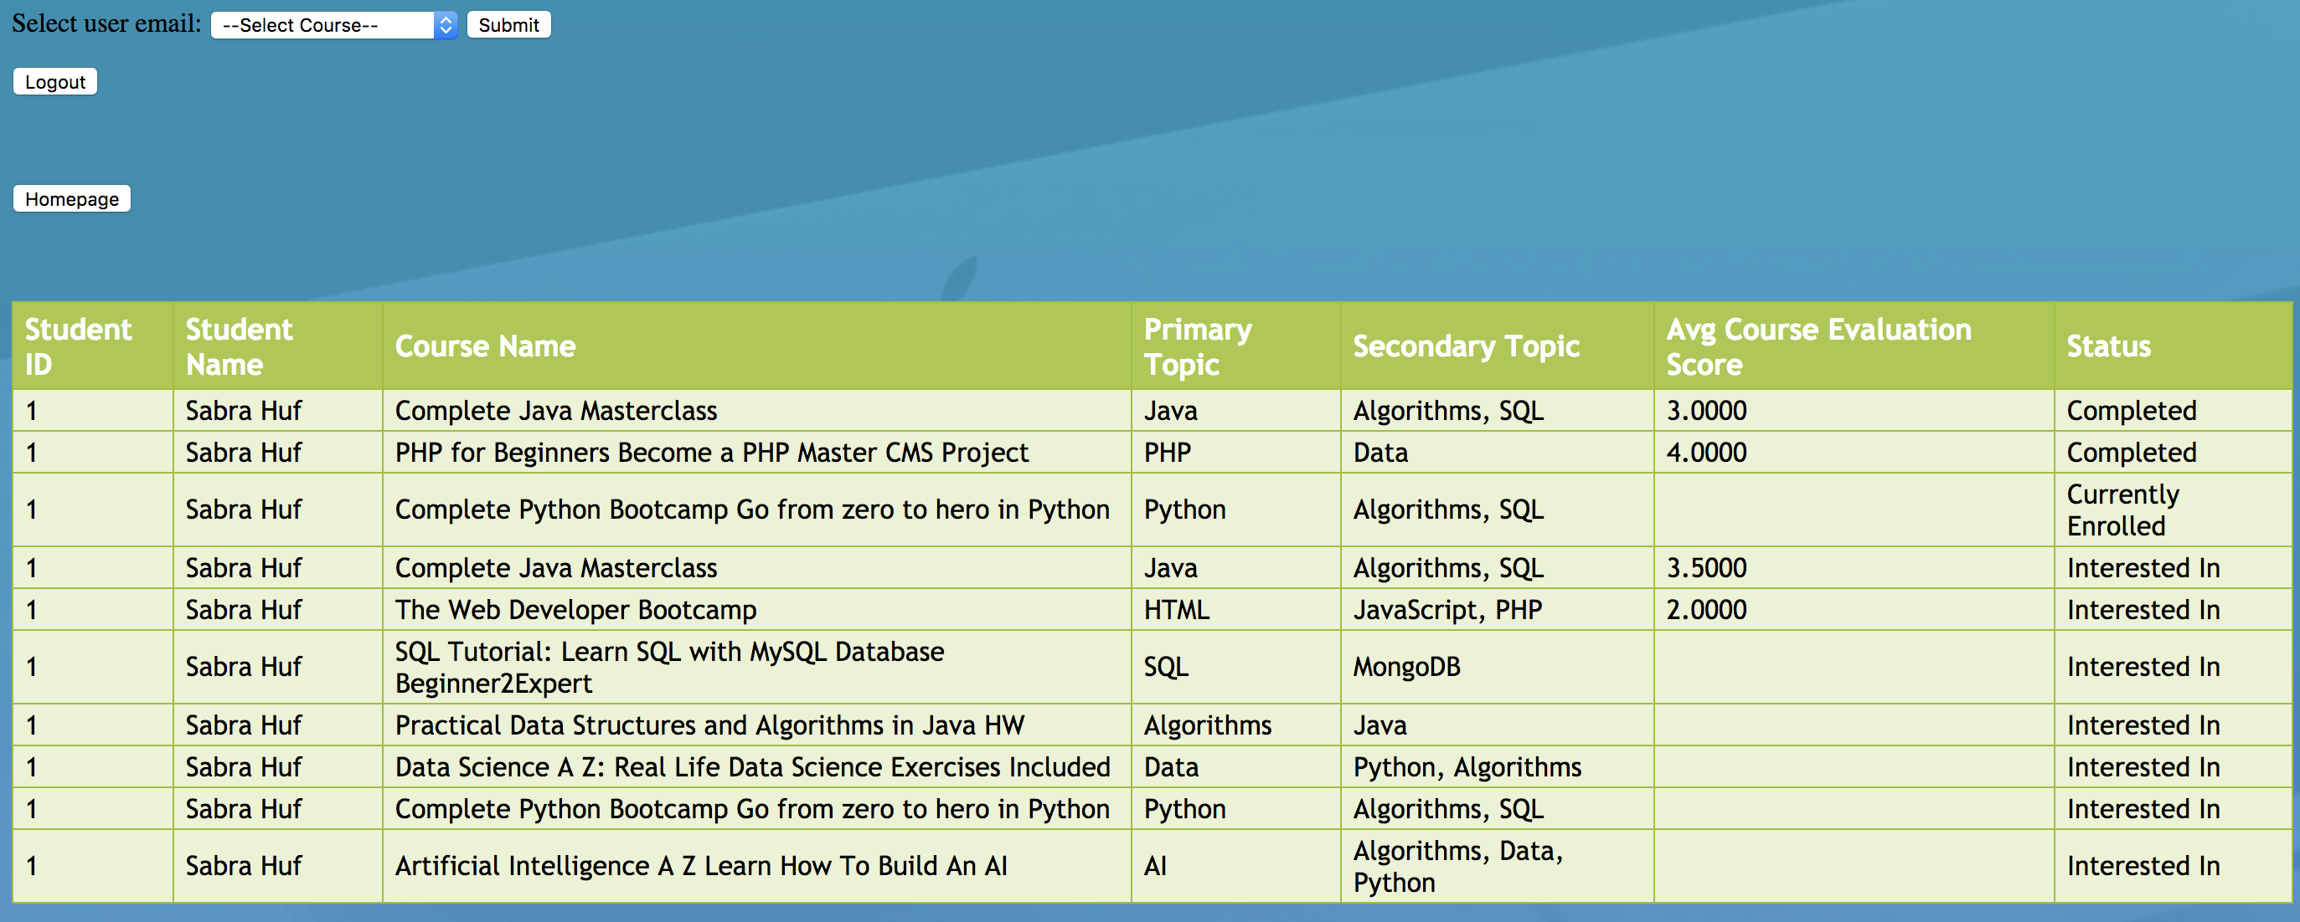

The above is the Task C and output, when you choose a student in admin account, it will show the Task C output. Also, this can be done in student account.

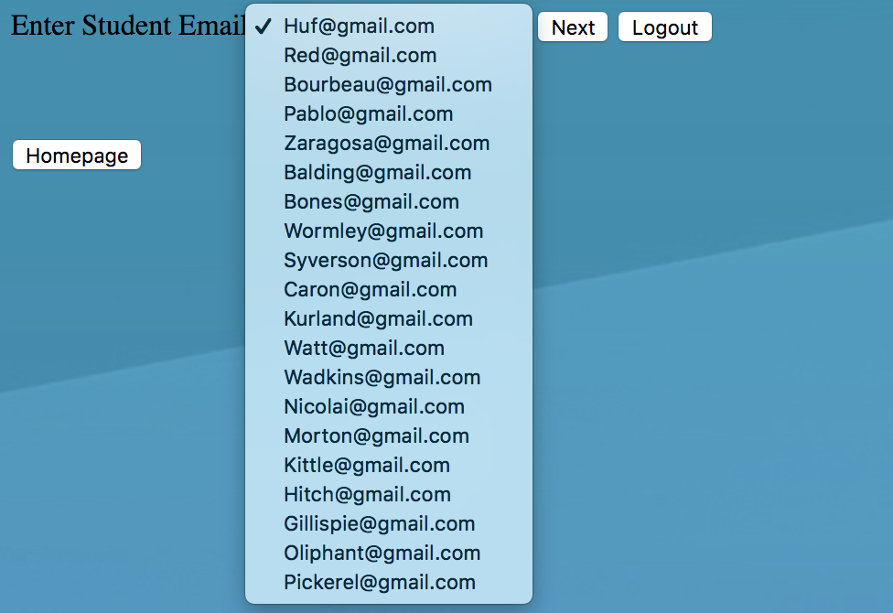

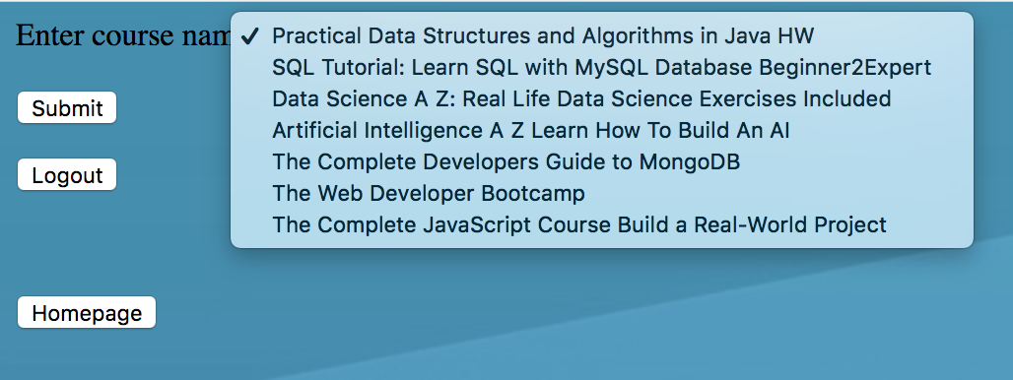

The above two images are the Task D forms, and this task is done by admin. When he chooses the both menus, it will show “new records updated successfully” and redirect to homepage for admin. And task D is done.

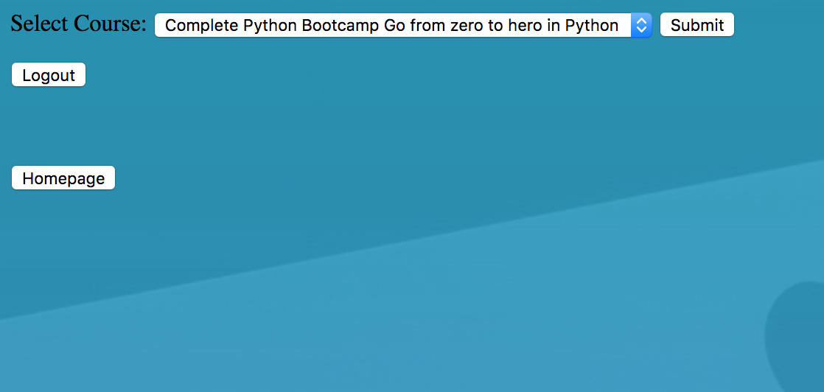

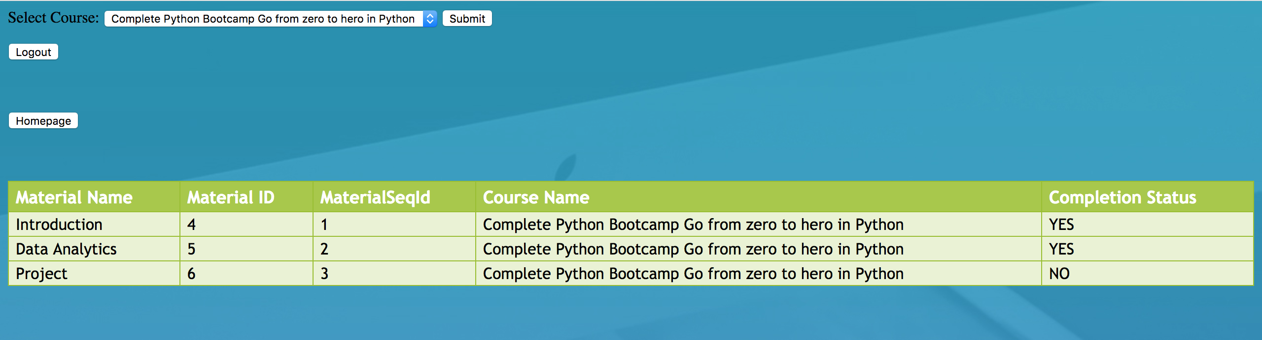

The above two images are Task E screenshots. And it is done by student.

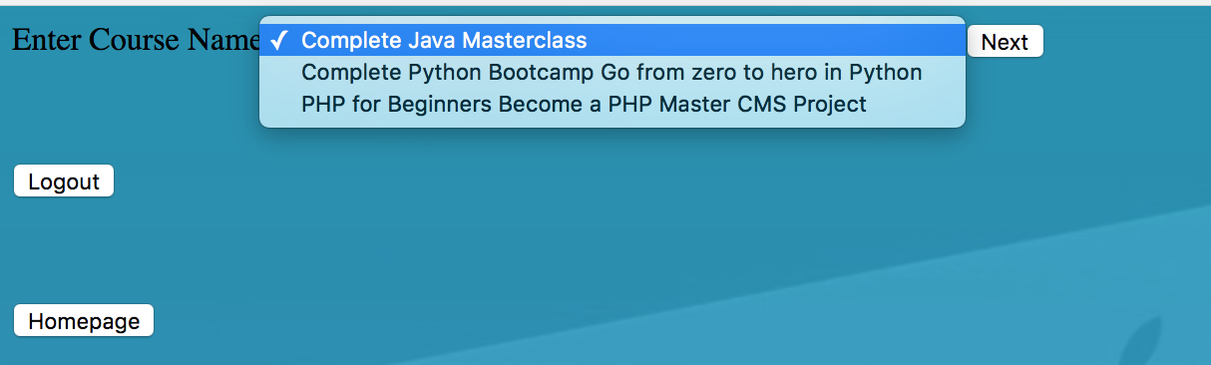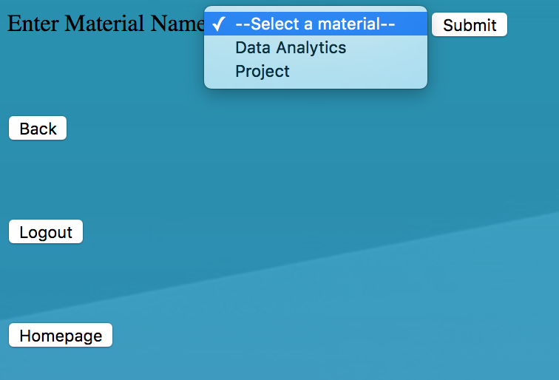

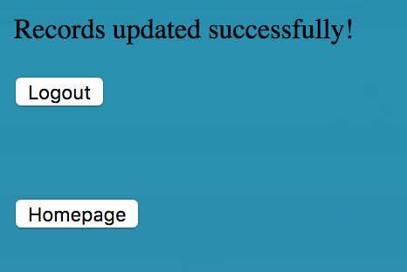

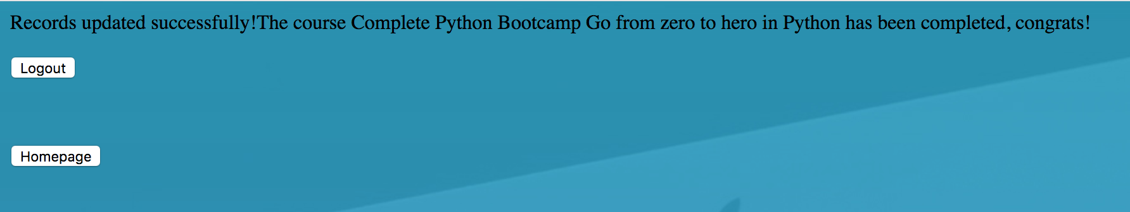

The above 4 screenshots are Task F, and it’s done by student. It will mark the course material as completed, and when all the materials for a course are completed, the course is marked as completed, too.

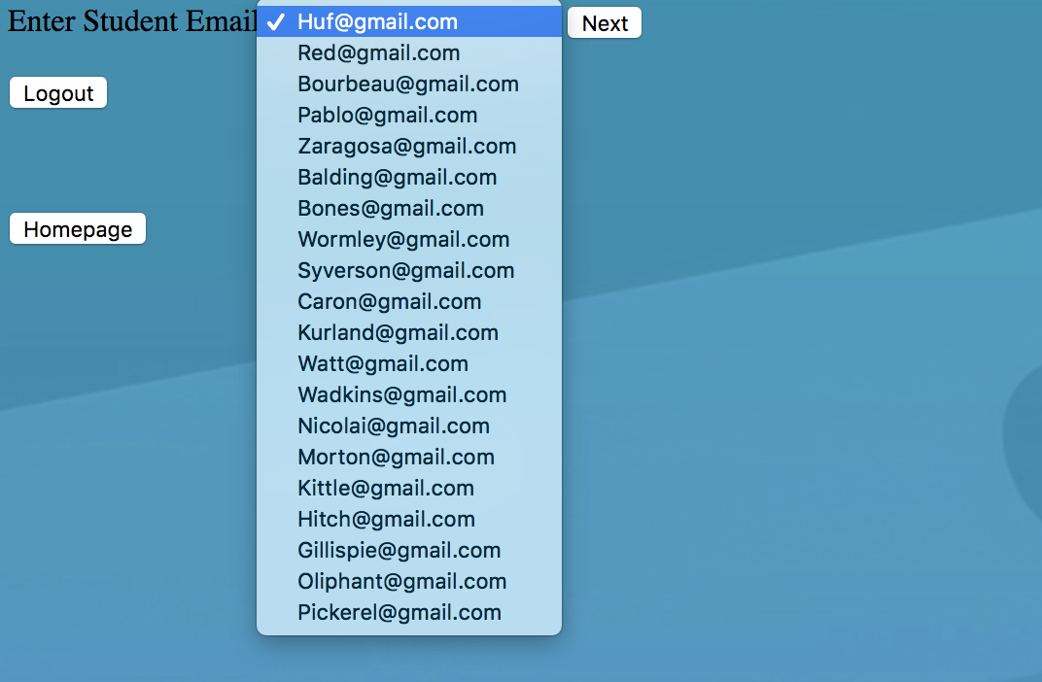

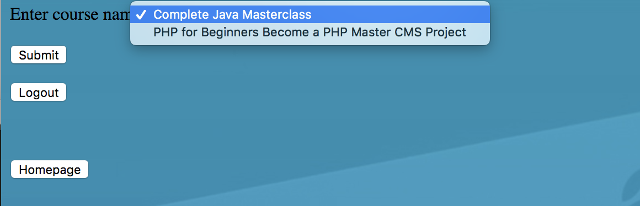

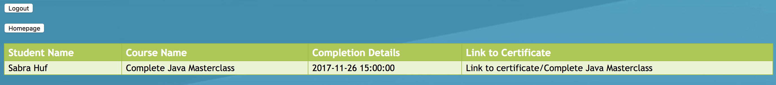

The above three screenshots are Task G, so it will provide a certificate for a student who enrolled in a course.

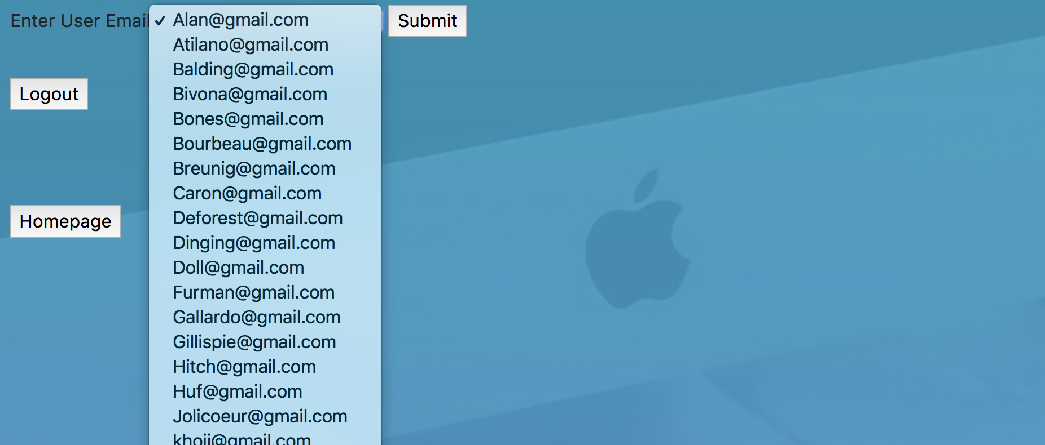

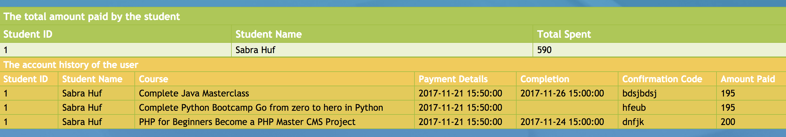

The above screenshots show the output of Task H. It’s done by admin, and it will show the account history for selected student. Also, this can be done by the student, and it will only show his own account.

**Project Retrospective**

In conclusion, we have learned a lot from the project, in addition to the knowledge we gained in our CS5200 course. We also learned how to build a web page with PHP from scratch. At first, we did not know anything about PHP, but after this project, we know how to connect the database using PHP, build simple website with HTML and CSS. Besides we also learned how to prevent SQL injection by using parameterization in the queries, which will remind us to sanitize the input and user parameter in our future work. In this project, the most attractive part is the connection between database and website, when we make it look like a real website where students, faculties and administrators can perform their roles, it really excited us. And the boring part would be the ERD and schema design, though it is boring, it is the basis. The easiest part is the creation of the database, with the Mysql Workbench, we can do this quickly and efficiently. And we found that the design of the website takes a lot of time since we did not know anything about web design, and so we had to learn it in a short time, it was tough but interesting as well.

We think the most meaningful part of this large project is to learn how to work like a team, work with people from different culture, we argued with each other, and it help us to become a better person. All of us enjoyed working for this project. Finally we would like to thank our professor Derbinsky, we love this class and we will keep going like this.

**Conclusion**

In conclusion, all the requirements for the project are accomplished by our group, and except that we build a website which can be used by the students, faculties and administrators. New user can register as one of the three types, and each role can perform certain tasks and complex queries. But there are still a lot of things needed for a great database, if we want to implement all these features that mentioned above, we still need to build more functions for the website, there should be things like student can post questions to a faculty, faculty can review the questions, administrator can manage the structure of the website. But due to time issues, we only implemented the features (tasks and complex queries) that are necessary for this project.